Magritte, René François Ghislain (1898–1967)

René Magritte was a Belgian artist who gained notoriety during the interwar period as a painter and for his involvement with Surrealism. His epigrammatic approach to painting, using collage-like juxtapositions and absurd transformations, developed from his preference for figurative representation and interest in the relation of images to poetic language. Although Magritte presented himself as contentedly bourgeois, his paintings were often intended to shock viewers by showing them what he called ‘the mystery of the world’. Magritte was born in the town of Lessines, but grew up in Châtelet where his father had become successful in the edible oil industry. Here he experienced a great childhood loss upon his mother’s suicide. Magritte first discovered painting as a boy, having encountered a painter working outdoors at an abandoned cemetery. In 1915, Magritte relocated to Brussels and soon undertook a brief period of study at the Académie Royale des Beaux-Arts until 1918. Magritte’s paintings during the early 1920s exhibited Futurist and Cubist influences. Collaborating closely during this period, Magritte and the abstract painter Victor Servranckx published an essay in 1922 entitled ‘Pure Art: A Defence of the Aesthetic’. Uneasy, however, with abstract painting’s reception as art for art’s sake, Magritte was deeply affected, in 1923, by what he called the ‘triumphant poetry’ of certain Giorgio de Chirico paintings emphasising the stillness and isolation of figures and objects. Magritte thereafter developed a similar approach to composition, as seen in The Lost Jockey (1926).

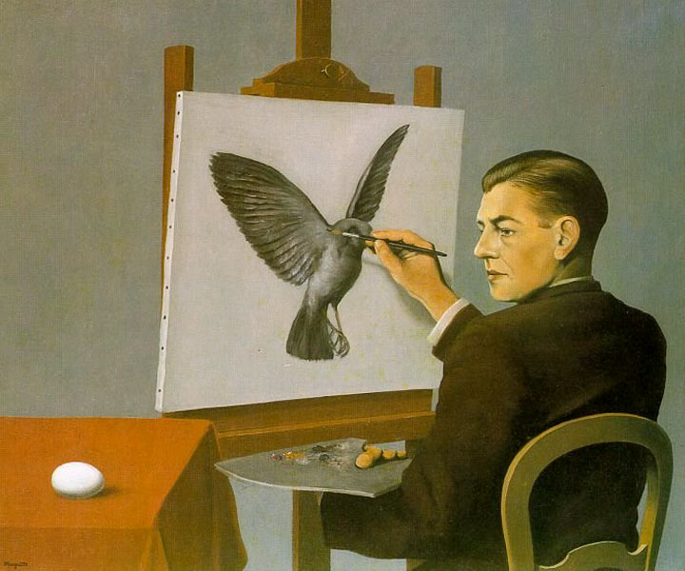

René Magritte, Clairvoyance (Self-Portrait), 1936

http://www.wikipaintings.org/en/rene-magritte/clairvoyance-self-portrait-1936

During the mid-to-late 1920s, Magritte helped establish the Belgian Surrealist group, the first international offshoot of the Parisian movement. To foster a closer alliance with the movement’s founder, André Breton (1896–1966), Magritte relocated to Paris in 1927. Here he began formulating his word-and-image paintings. In The Hidden Woman (1929), Magritte combined a nude female figure and painted words into a rebus that read ‘I do not see the [woman] hidden in the forest’. Despite the praise Magritte received from Breton’s circle for his contributions to the group’s journal La Révolution Surrealiste, Breton himself would not write about Magritte’s work until 1964. Strained relations with the Surrealists in Paris influenced Magritte’s return to Brussels in 1930.

Despite having to work as a commercial artist throughout his career, Magritte remained an innovator in modern art after his return to Belgium. Formerly his images had relied on illogical juxtapositions to shock the viewer, whereas certain paintings of the 1930s onward posited two states of a single object seemingly logical in isolation but palpably unsettling when presented together, such as the egg and bird in Clairvoyance (1936).

Magritte’s lasting legacy was aided by the popularity of a single work, The Treachery of Images (1929), which presents the image of a tobacco pipe with the words ‘this is not a pipe’ painted below it. This work garnered much critical attention including that of French philosopher Michel Foucault, whose commentary on the piece, entitled This is Not A Pipe, was published in 1968. Today this painting resides in the Los Angeles County Museum of Art, while many other Magritte works are housed at the Musée Magritte in Brussels.

References and further reading

Sylvester, D. and S. Whitfield (1992) René Magritte, London; New York: Menil Foundation; Philip Wilson Publishers.

Whitfield, S. (1992) Magritte, London: South Bank Centre.

Gablik, S. (1985) Magritte, London: Thames & Hudson.

Sylvester, D. (1992) Magritte, New York; Brussels: Menil Foundation; Mercatorfonds.

Allmer, P. (2009) René Magritte: Beyond Painting, Manchester: Manchester U.P.

Canonne, X. (2007) Surrealism in Belgium, 1924-2000, Brussels; London: Mercatorfonds; Thames & Hudson.

Breton, A. (2002) Surrealism and Painting, Boston; New York: MFA Publications.

http://vimeo.com/4991360 (Interview with Magritte on the subjects of poetry, familiarity, strangeness, desire, and logic. Excerpt from 1978 film Monsieur René Magritte, directed by Adrian Maben. Language: French).

http://www.wikipaintings.org/en/rene-magritte (Online gallery of over 300 Magritte paintings, including early works and variants, organized either chronologically or alphabetically).

